1- Download SQL Server 2022 Developer Edition

<https://www.microsoft.com/en-us/sql-server/sql-server-downloads>

2-Go to Download then double click on

SQL2022-SSEI-Eval.exe

3-choose custom

4- after loading -🡪 choose installation

[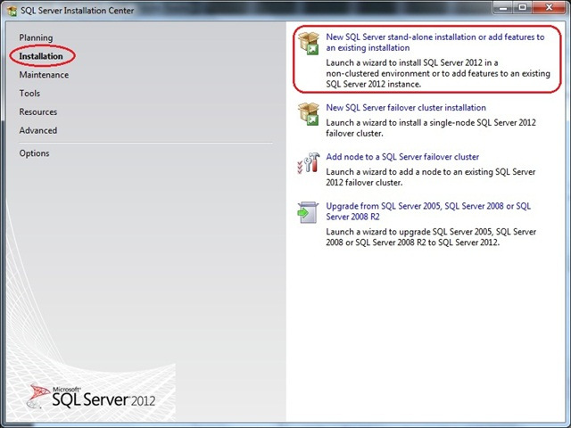](http://basitaalishan.files.wordpress.com/2012/06/021.jpg)

5-Next 🡪 Next then from features choose only 3

**DB engine**

**Analysis service**

**Integration service**

6- choose default instance

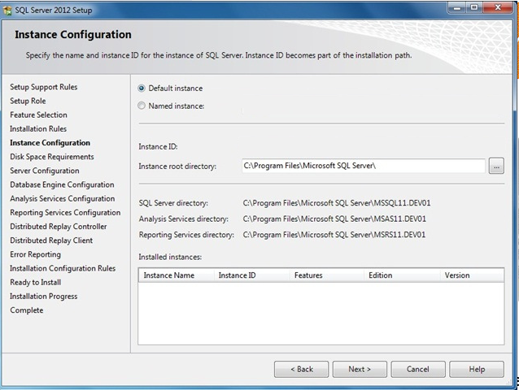

7-windows authentication

--- add current user

8- choose Multidimensional mode for analysis service

----add current user

9- choose Install

10-Setup SQL Server Management Studio

<https://learn.microsoft.com/en-us/sql/ssms/download-sql-server-management-studio-ssms?view=sql-server-ver16&redirectedfrom=MSDN>

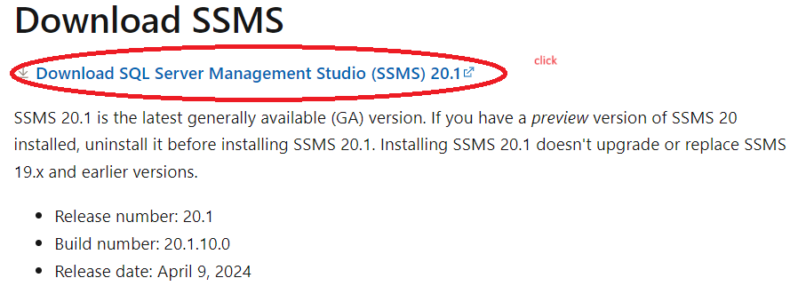

11-Download and Install SQL server Reporting Service

<https://www.microsoft.com/en-us/download/details.aspx?id=55252>

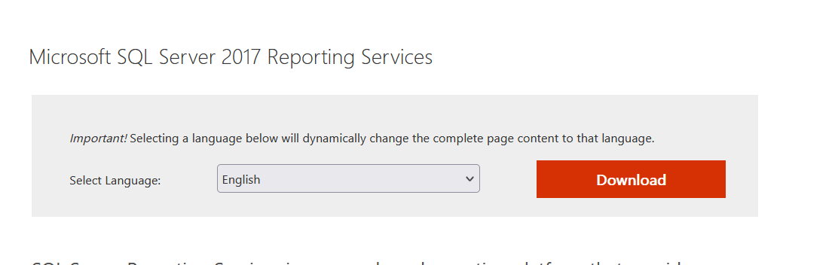

12- Download VS2022 **Community**

<https://visualstudio.microsoft.com/downloads/>

13- Select **SQL Server Data Tools** under **Data storage and processing** in the list of workloads.

[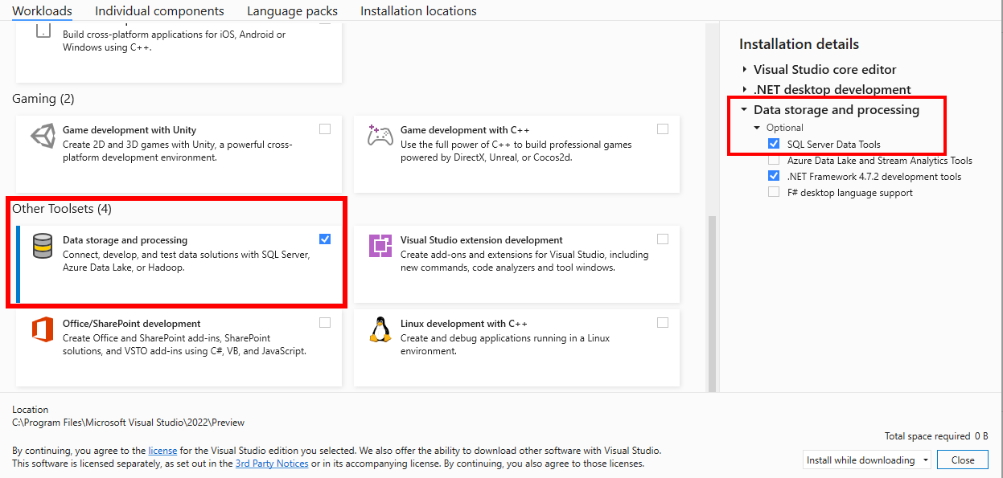](https://learn.microsoft.com/en-us/sql/ssdt/media/download-sql-server-data-tools-ssdt/data-workload-2022.png?view=sql-server-ver16#lightbox)

14- after installing VS Restart PC

15-Now We Need to Enable BI Projects ON Visual Studio but we should ensure that VS and SQL Server are closed

16- Download and Install Integration service Project

<https://marketplace.visualstudio.com/items?itemName=SSIS.MicrosoftDataToolsIntegrationServices>

17-after installation Restart PC

18 -Download and Install Analysis services Projects

<https://marketplace.visualstudio.com/items?itemName=ProBITools.MicrosoftAnalysisServicesModelingProjects2022>

19- after installation Restart PC

20- Download and Install Reporting service Project

<https://marketplace.visualstudio.com/items?itemName=ProBITools.MicrosoftReportProjectsforVisualStudio2022>

21- after installation Restart PC

**Good Luck**